# Design guidelines

## Consistent layout

We should use layout pages to keep the layout consistent. You can find the layout page (master page) under Views/Shared/_Layout.cshtml. Open it up and take a look at it. To add a new layout page just right click in the Shared folder and click “Add new item” (Ctrl + Shit + A). 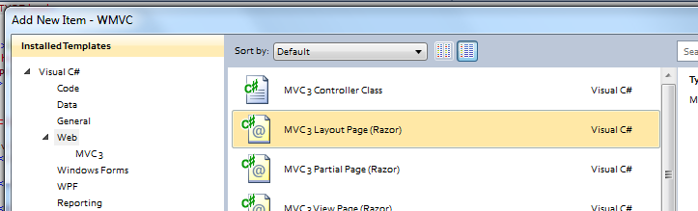

Choose MVC Layout Page to add a new layout page.

**The things you need to be concerned about in a layout page are:**

@RenderBody() This tag in the layout page indicates where the content of the view should be placed.

The content of @using (Html.BeginForm()) on your view will replace the @RenderBody tag in the layout page.

@RenderSection("Footer", false) If the design of your views need to be split up or if you need to add a component outside your main view, you should use the RenderSection tag inside the layout page. The false parameter tells us that it is optional for the view to have this section i.e. the layout page can provide support for an individual footer for each view that uses this layout page, but the views doesn’t need to have a footer.

The views that have a footer should place it inside a

@section Footer  
{  
    <h1>This is my footer</h1>  
}

## Reuse components

If you create a component that can/should be reused (menu or page header) you should create a partial view(mvc’s usercontrols). To create a new partial view select the Shared folder under Views and “Add new item” - > MVC 3 Partial Page(Razor).

You don’t need to add the <html>, <head> and <body> tags, since they already are added in the layoutpage.

To use the partial page inside a view or a layout page, just add the

@Html.Partial("_Status") tag where you want the partial page to appear. “_Status” = name of your page.

## Use fluid layouts

The screen should display correctly on different screen resolution. Avoid absolute values, use 50% instead of 512px etc.

## Avoid formatting tags in views

Don’t use <b>header</b> on every header in your views, instead create a new css class called “header”.

Just edit Site.css under the Content folder.

#header  
{  
 font-weight:bold;  
}

And use <div class="header">header</div> in your view page.

## Uniform look

We should create a uniform look by using the same css styles for the same controllers. So if you insert a new controller, either check in the stylesheet if a style exist for that controller or go together with some other team members and try to create a new style that fits general design.